**Daily Scrum or Standup Meeting**

Team name: 5th Element

Scrum Master: Leonardo Craven

Date: November 12, 2021

| **Team Member** | **What did you do since the last scrum?** | **What do you plan to do before the next scrum?** | **What obstacles do you have?** |
| --- | --- | --- | --- |
| Leo | Finish notifications page | Update diagrams and planning documents with changes this sprint  Make sure notifications created when order complete | None |
| Gavin (not present at meeting) |  |  |  |
| Andrew | Worked on app logo, navigation sidebar | Add items to navigation sidebar, work on adding sidebar to all pages | None |
| Brock | Worked on company account migration | Finish company account migration (done Monday) | None |

# Burndown

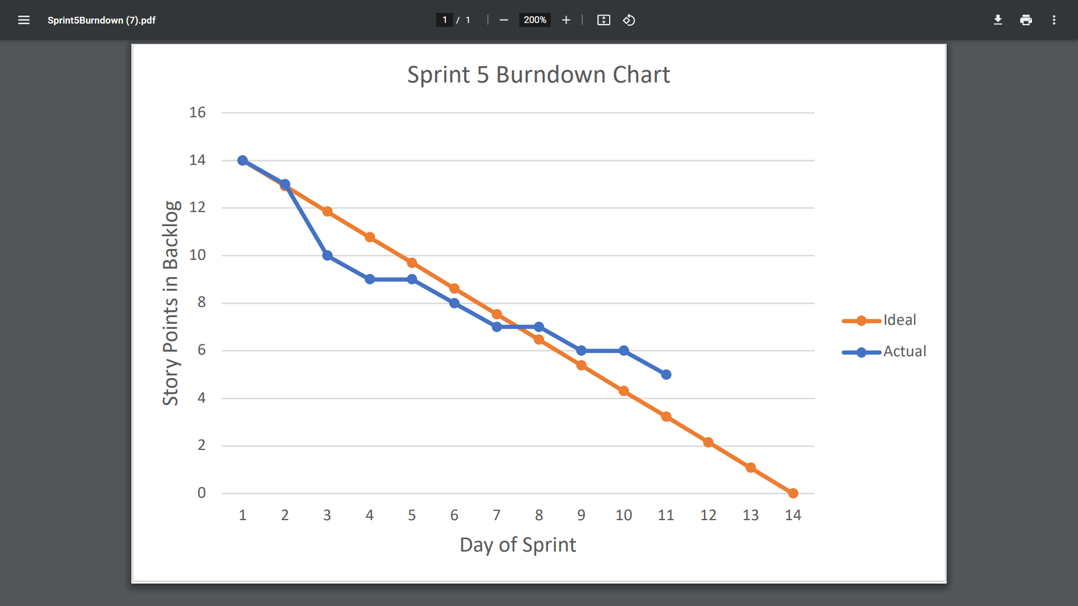

# Screenshot of you project board

